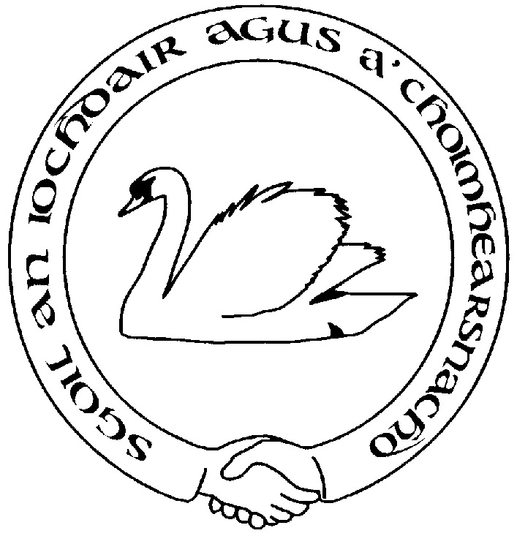

IOCHDAR PLAYING FIELDS ASSOCIATION

Membership subscription form

When you become a member of our association, you will get copies of our minutes, additional information about our activities, and the opportunity to suggest projects and stand for election to the board of trustees. Your community group can adopt our policies and we can work jointly on projects

To subscribe to our organisation, please complete this form and return to Dr Kate Dawson at the Old School House, Iochdar, South Uist.

If you are subscribing as an organisation, please enter the name of your representative.

Name: date:

Organisation:

Address:

Tel: email:

Please enclose payment as follows, and indicate which category
- Community group £5 per year
- Individual membership £1 per year
- Individual membership £10 for 10 years

For BACS, please make payment to
Branch code: 80-05-60
Account number: 00236499

PTO for privacy information
PRIVACY NOTICE

When you join Sgoil an Iochdair agus a’Choimhearsnachd as a member, you are asked to pay a nominal subscription fee, and to give us your contact details. This paper form is filed in the secretary’s office. If your membership lapses, the form is then shredded.

In addition, the data provided in your subscription form is added to a digital database for emails and postal communication about the activities of the organisation. This is filed on the secretary’s computer which is protected by a secure password.

Your contact details are only used by us, and not shared with any third parties.
The number of members is reported at the Annual General Meeting, and the names of members attending the AGM are recorded in the minutes.

Please refer to our GDPR privacy policy for full details. The policy is available on our website, and can be requested from our Secretary:

Dr Kate Dawson,
The Old School House
Bualadubh
Isle of South Uist
HS8 5RQ

kate@iochdar.co.uk

